Tutorial 03

Our Work

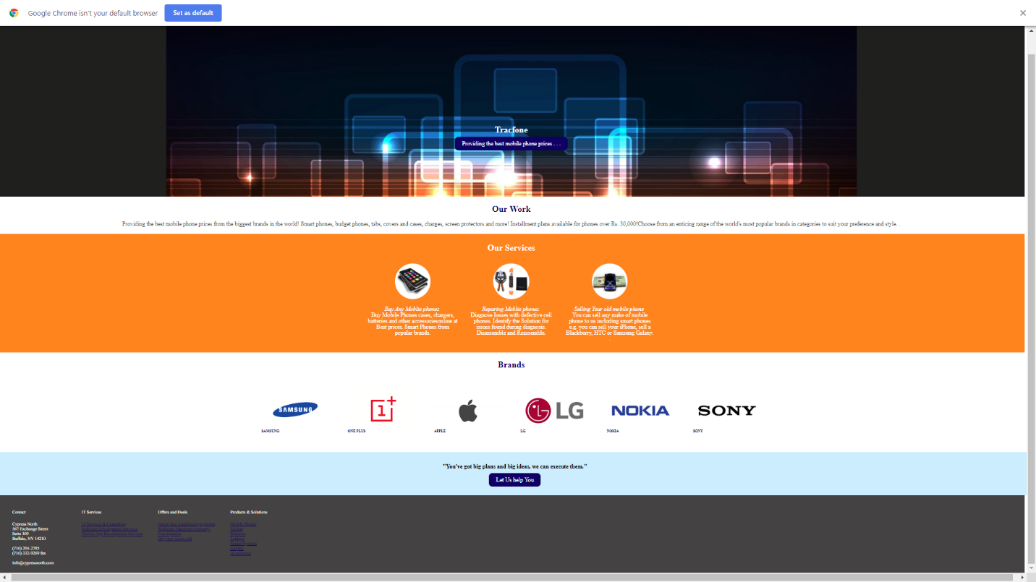Providing the best mobile phone prices from the biggest brands in the world! Smart phones, budget phones, tabs, covers and cases, charges, screen protectors and more! Installment plans available for phones over Rs. 30,000!Choose from an enticing range of the world's most popular brands in categories to suit your preference and style. .

Buy Any Mobile phones

Buy Mobile Phones cases, chargers, batteries and other accessories online at Best prices. Smart Phones from popular brands.

Repairing Mobile phones

Diagnose Issues with defective cell phones. Identify the Solution for issues found during diagnosis. Disassemble and Reassemble.

Selling your old mobile phone

You can sell any make of mobile phone to us including smart phones e.g. you can sell your iPhone, sell a Blackberry, HTC or Samsung Galaxy

